LEARNING REFLECTION PLATFORM

A Synopsis for
Minor Project
BACHELOR OF TECHNOLOGY in COMPUTER SCIENCE & ENGINEERING
BY
Amita Kumari EN23CS301121
Anaaya Bhattacharya EN23CS301123
Anjali Gour EN23CS301136

Under the Guidance of

Prof. Deepika Saraswat

Prof. Jyotsana Goyal

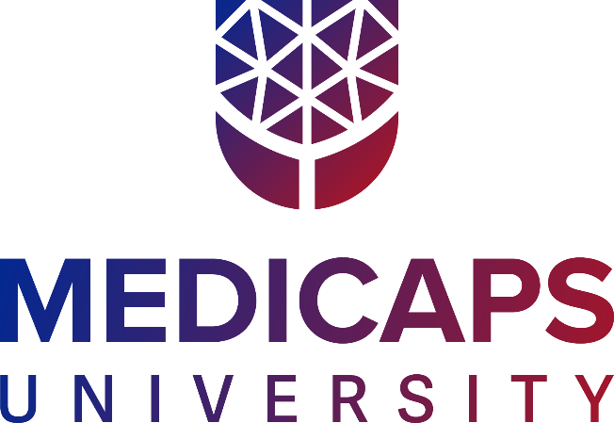

Department of Computer Science & Engineering Faculty of Engineering
MEDICAPS UNIVERSITY, INDORE- 453331

Jan - June 2026

Introduction
- In today’s digital era, students consume learning content from multiple sources such as YouTube, blogs, documentation websites, and shared links YouTube
- Often, students are unable to fully understand a concept immediately due to:
  - Time constraints
  - Lack of prerequisites
  - Cognitive overload
- These resources are saved with the intention of revisiting them later.
- However, there is no structured mechanism to track conceptual understanding or readiness.
- Learning Reflection Platform is designed to solve this problem by focusing on learning clarity rather than task completion.

Literature Review
1. Task Management Platforms (Todo list, Notion)
- Organize tasks and deadlines
- Focus on completion tracking
- Do not support conceptual understanding or learning clarity
2. Learning Management Systems (LMS) (Moodle, Google Classroom)
- Structured course delivery & assessments
- Institution-controlled platforms
- Limited support for self-directed external learning resources
3. Reflective & Self-Regulated Learning
- Research highlights importance of metacognition & reflection
- Tracking conceptual clarity improves retention & exam readiness
- No structured tool for managing unresolved learning concepts
Identified Gap
Existing tools either:
Manage tasks or Deliver content
⚠️ But they do not support structured tracking of unresolved learning items in self-directed learning.

Problem Definition
In today’s digital learning environment, students use multiple platforms (YouTube, blogs, documentation, shared links).
Challenges
- Time constraints
- Lack of prerequisites
- Cognitive overload
- Poor organization
Students save resources to revisit later, but:
- Links get scattered
- Unresolved concepts are forgotten
- No structured clarity tracking
- Tools focus on task completion, not understanding
- No system to prioritize before exams/interviews
Result
Important concepts remain partially understood or forgotten, affecting academic performance and preparation readiness.

Objectives
- The main objectives of the Learning Reflection Platform are:
- Provide a centralized platform for managing learning resources
- Track learning progress based on clarity:
  - Confused
  - Partially Clear
  - Clear
- Allow users to set target readiness dates
- Encourage reflective learning through difficulty identification
- Provide reminder mechanisms
- Track interaction and revisit frequency

Methodology
1. Development Approach
The Learning Reflection Platform will follow a modular and incremental development approach.
- The system will be divided into independent modules.
- Each module will be designed, implemented, and tested separately.
- Integration will be performed after validating individual components.
- This approach will ensure scalability, maintainability, and structured growth of the system.
Proposed modules include:
- User Authentication Module
- Learning Item Management Module
- Metadata Extraction Module
- Reminder & Priority Evaluation Module
- Interaction Tracking Module

2. System Architecture
The platform will follow a Client-Server Architecture.
Frontend Layer:
- Will be developed using HTML5, CSS3, JavaScript, and React.js.
- Responsible for user interface, dashboards, and interaction controls.
Backend Layer:
- Will be built using Node.js and Express.js.
- Responsible for business logic, API handling, and data processing.
Database Layer:
- MongoDB will be used for storing user data and learning items.
- Mongoose will define structured schemas.
Communication between frontend and backend will occur through REST APIs using JSON-based HTTP requests.

3. Functional Workflow
The proposed system workflow will be:
- Users will register and log into the platform.
- Users will add learning resource links.
- The backend will process the link and extract metadata.
- Learning items will be stored in the database.
- Users will set clarity level, difficulty reasons, priority, and readiness date.
- The system will evaluate deadlines and generate reminders.
- User interactions (such as link visits) will be tracked for analysis.
This workflow ensures structured learning reflection rather than simple task tracking.

Societal impact or benefits to society
1. Promotes Structured Learning Habits
The platform encourages students to:
- Reflect on what they do not understand
- Track conceptual clarity
- Revise before important deadlines
2. Supports Self-Directed Education
With the rise of online learning platforms such as YouTube, Coursera, and Udemy, students increasingly learn independently. This platform helps to manage resources efficiently.
3. Reduces Learning Gaps
By tracking:
- Confusion levels
- Difficulty reasons
- Readiness deadlines
4. Encourages Reflective Thinking
The system applies principles of self-reflection, metacognition, and active learning. Students move from passive content consumption to active understanding evaluation. This improves long-term retention.
5. Improves Academic & Career Preparedness
By setting readiness deadlines for:
- Exams
- Competitive tests
- Job interviews Students prepare in a structured and timely manner.
6. Digital Organization & Productivity Enhancement
The platform reduces:
- Scattered saved links
- Forgotten bookmarks
- Unused study materials
Conclusion
The Learning Reflection Platform addresses a critical gap in modern digital education by focusing not on task completion, but on conceptual understanding and reflective learning.
In today's environment, students consume large amounts of online educational content but lack a structured way to track what they do not understand. Existing systems either manage tasks or deliver content, but do not support clarity tracking and learning reflection.
Platform Provisions
This platform provides:
- Centralized management of learning resources
- Clarity-based progress tracking
- Difficulty reflection mechanisms
- Priority and readiness-based reminders
- Interaction tracking for accountability
Student Benefits
By integrating structured organization with reflective learning principles, the system helps students:
- Reduce conceptual gaps
- Improve exam and interview readiness
- Develop disciplined and self-regulated learning habits

